A.freddy chris

(01/10/2020)

**Internship Training Document**

* What is internet?

The Internet is the global system of interconnected computer networks that uses the Internet protocol suite (TCP/IP) to communicate between networks and devices.

* How Does the internet works?

my Computer information-1 information-1 Another Computer

internet

It's important to realize that the Internet is a global network of **physical cables**, which can include copper telephone wires, TV cables, and fiber optic cables. Even wireless connections like Wi-Fi and 3G/4G rely on these physical cables to access the Internet.

When you visit a website, your computer sends a request over these wires to a Server. A server is where websites are stored, and it works a lot like your computer's hard drive. Once the request arrives, the server retrieves the website and sends the correct data back to your computer. This all happens in just a few seconds

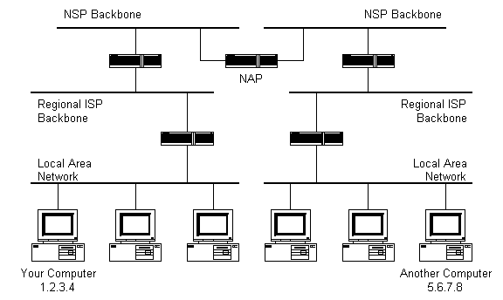

1. Local Area Network

LAN is a collection of devices connected together in one physical location, such as a building, office, or home.

1. ISP

Internet Service Provider used fiber-optics, satellite, copper wire, and other forms to provide Internet access to its customers.

1. NAP

Network Access Point is a set of operating system components that provide a platform for protected access to private networks.

1. NSP

This includes [fiber optic](https://techterms.com/definition/fiber_optic_cable) lines between hubs or "Internet exchanges" that route Internet traffic around the world. These communication lines offer extremely high [bandwidth](https://techterms.com/definition/bandwidth) of hundreds or even thousands of [gigabits per second](https://techterms.com/definition/gbps). The global network created by multiple NSPs enables data to flow seamlessly between computer systems around the world.

